Rafael RODRIGUEZ-LEAL T., obtained his B.A. in Environmental Analysis and Design from the University of California at Irvine. He later obtained his Masters degree in Public Policy and Administration from the *School of International and Public Affairs* (SIPA) at Columbia University in NY, with a dual specialization in *Economic and Political Development* and *International Security Policy*. Jobs he has performed have been with the *United Nations Office for Disarmament Affairs* (UNODA) in New York (2008), the *Women Refugee Commission* (WRC) working on a project in northern Uganda for the *NRC* (2009), and with the *United Nations Stabilization Mission in Haiti* (MINUSTAH) (2012-2015). Today he is a researcher at the Motolinía University in Mexico City and participates at a Human and Social Rights seminar at the National and Autonomous University of Mexico. Rafael realized a journey to Tibet at age 19 and he loves to travel. He is a native of Mexico City.

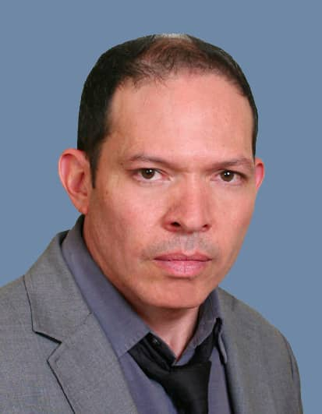

**Project Coordinator**

Pierre Antoine BLAISE was born in the city of *Les Perches* in Haiti. He completed his education in Juridical Sciences at the *Law, Economics and Management Faculty* in Haiti in 2009. Pierre Antoine continued his trajectory participating in his community in *Les* *Perches* where he started his teaching career in 2006 at the *Ecole Nationale Supérieur* de *Les Perches.* Pierre Antoine learned different abilities, developed his sense of leadership and put himself at the service of the youth directing literary clubs and serving as an example of success and hope. He never looses the opportunity to actively participate in civil society organizations. His sense of responsibility and his experience allowed him to be appointed Mayor Principal of the commune of *Les Perches* from 2012 to 2015. His titanic work within his community left many projects accomplished. Pierre Antoine, serves with a constant dedication to the youth of his country and to the development of the commune of *Les Perches*. Mr. Blaise likes Haitian Racine and Reggae, specially Bob Marley.

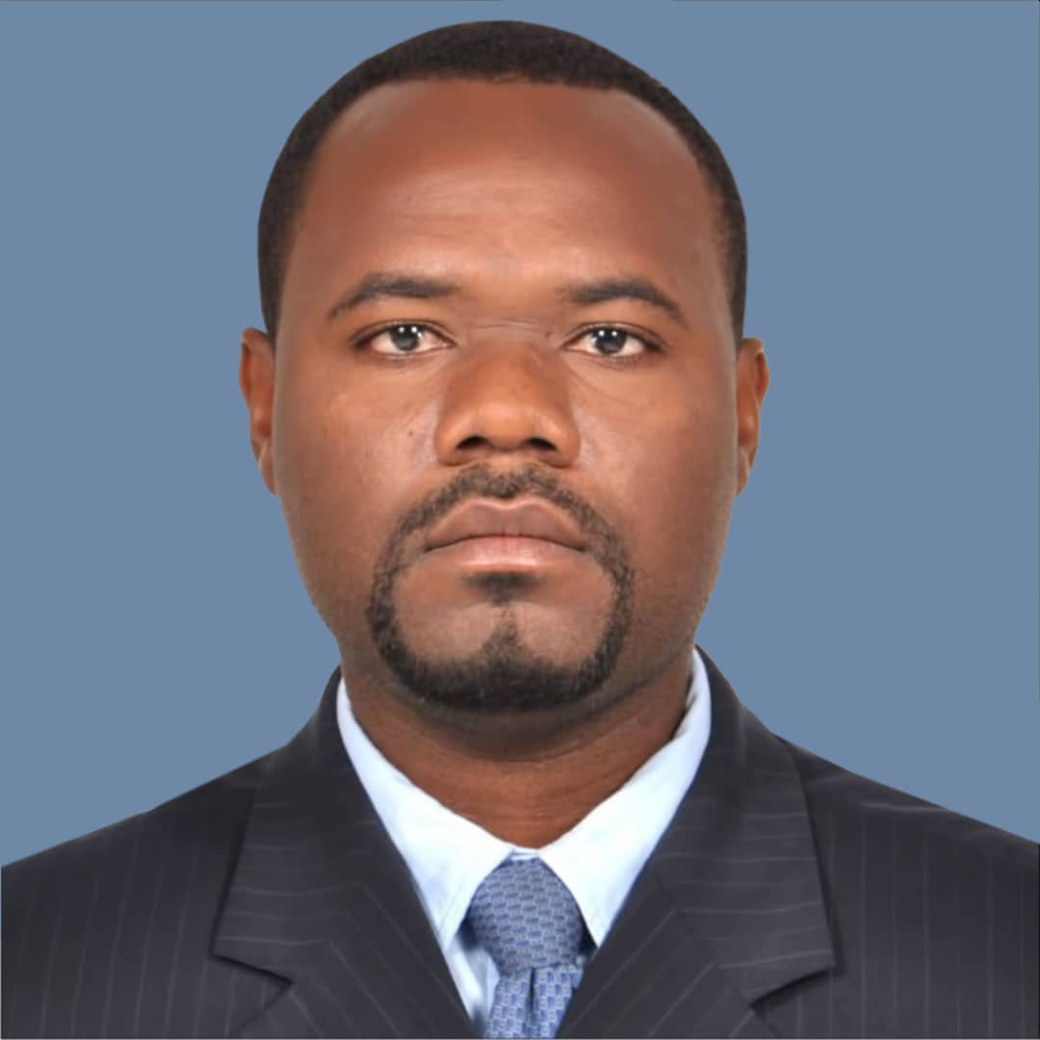

**Legal Adviser and Rule of**

**Law Specialist**

Jesula BLANC, is a translator, professor, and human rights advocate. Her objective is to work for a violations and machismo-free and new society, to contribute in the improvement of bilateral relations between Haiti and the Dominican Republic. Jesula is about to finish her B.A. in Law from the Law and Magistrate Faculty at the Jean Price University in Ouanaminthe. From 2006 to 2008, Jesula studied languages and translation at the Quisqueya University of Haiti in Port-au-Prince and Spanish from January to December of 1999 at the Center of Dominican-Haitian Languages in Dajabón, Dominican Republic. From November of 2015 to date Jesula has worked for GARR (Groupe d’Appui aux Rapatries et Refugiés) as expert in advocacy to guide in the defense of vulnerable persons overall the users of the Ouanaminthe-Dajabón border. She also worked as Operator-Trainer of the Communications-Center (COMCENTER) of the United Nations Stabilization Mission in Haiti (MINUSTAH) from 2009 to 2015. Jesula likes to dance kompa, salsa and bachata.

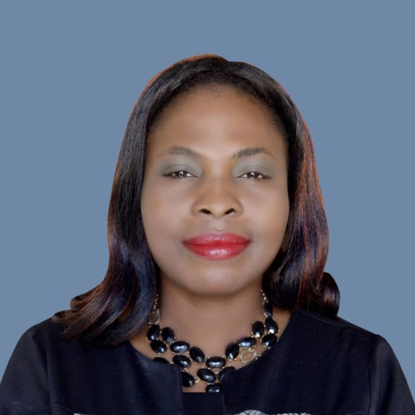

**Gender Equality Specialist**

**and Executive Secretary**

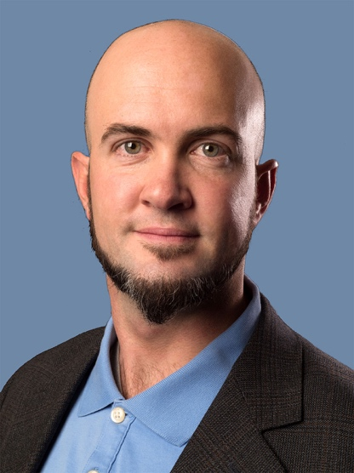

Travis CHAMBERLAIN, graduated from *University of California at Irvine* with two degrees, one *B.A. in Philosophy* and a second in *Economics* in 2006. While he studied his B.A. degrees, Travis, in collaboration with other peers, was able to raise funds in a total of $ 15,000, that they donated to the fabrication of prosthesis for youth who have lost one of their extremities. Travis also attended the *London School of Economics* in 2009, where he received his Masters of Science in the Philosophy of Public Policy. Travis has continued his education at the *University* *of California in San Diego (2019)*, now in his sixth year as a student in the doctorate of Philosophy and Science Studies, specialized in the measurement of human wellbeing. Travis aims to follow a career in Non Profit Organizations, with the hope of helping as a member of the team and specialist in measurement and evaluation. Travis loves to surf.

**Measurement, Evaluation,**

**Philanthropy Projects and Fundraising Specialist**

Vikram KANNEGUNDLA, graduated from *University of California San Diego* (UCSD) in 2008 with a B.A. in *Structural Engineering*, he has worked on interesting projects in the United States. Among them, he distinguished himself as, potentiometer and programs integration technician at *Xerox Corp* (1998-2001) in NY; as a civil engineer at *Green Structures* (2008-09) in San Diego; as data analyst of petroleum Wells and petroleum engineer at *Baker Hughes* (2011-12) in Texas; as maintenance, machinery and equipment technician, at *Arroweye* (2012-13) in Las Vegas; and as finance auditor for *William Hill* (2013-present) also in Las Vegas. Furthermore, Vikram decided to re-enter university in 2018 to obtain a second B.A. degree in Accounting, within the *American Public University System*, and in such goal augment his competencies and abilities in the financial sector. Vikram is a fan of different genres of music including Rap, Hip-hop R&B and Techno, and he is a native of the City of Hyderabad, in the state of Andrah Pradesh in India.

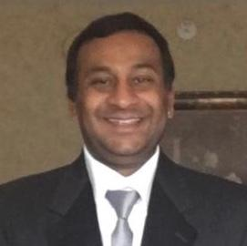

**Technical Operations Specialist**

**for Environmental Projects**

Mr Robert HONORÉ, a graduate of the University, has worked for the United Nations Mission for the Stabilization of Haiti (MINUSTAH) in the Northeast Department from 1995 to 2015 as Administrative Manager of the Civil Affairs Section of MINUSTAH. Robert collaborated with the section on interesting quick impact projects, QIPs, for its acronym in English. He was responsible for the management of the correspondence, archives, and billing by engineers who carried out Quick Impact Projects (QIPs). He was also in charge of processing the reimbursements for all officers of the civil affairs sections in the northeast, which they were entitled to for travel or training and lodging. Mr Robert stood out for his great organizational skills and good humor. He loves to listen to politics on the radio, Kompa, and to eat and drink papaya and coffee, respectively, in the mornings.

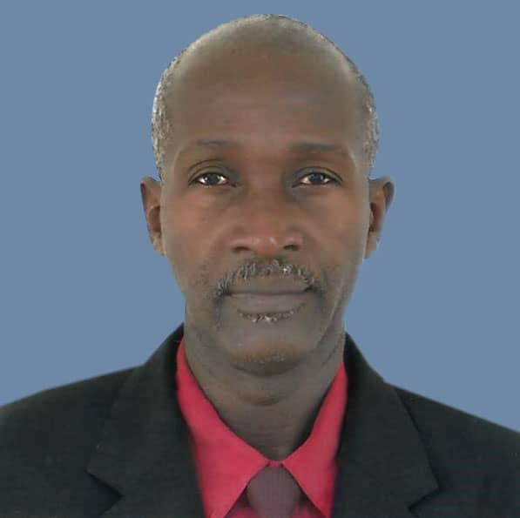

**Project Coordinator Assistant**

**in charge of**

**Administrative Management**

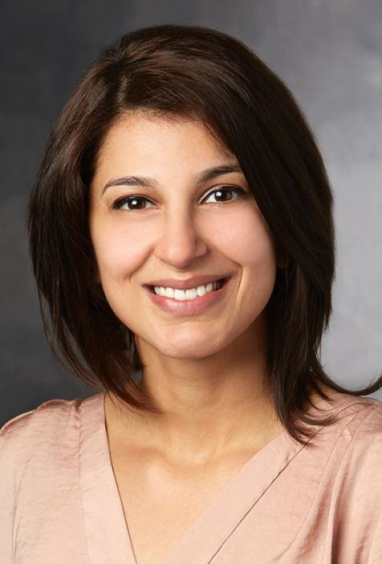

Ms. Ayesha is a graduate of Stanford University in California. She is a doctor and a teacher in the medical school of such university. Ayesha has worked with the organization, *Empower and Advance* in Haiti and multiple other countries. In the community of Les Perches, in Haiti, she helped developed with the support of the Municipality, the first medical dispensary to provide medicines to the members of the community. Miss Ayesha loves to travel, to sign Karaoke and to dance.

**Health and**

**Assistance to vulnerable communities**

**Project Specialist**